

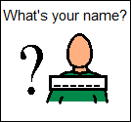**Complaint Form**

**: _________________________________**

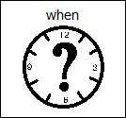

**: _________________________________**



**What is the problem? (Please circle)**

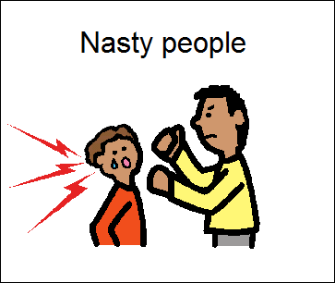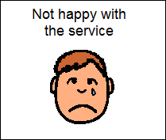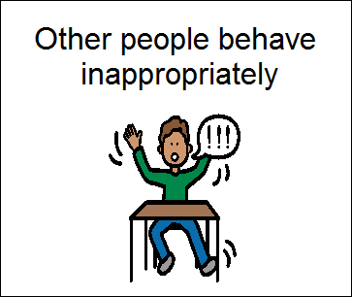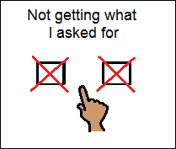

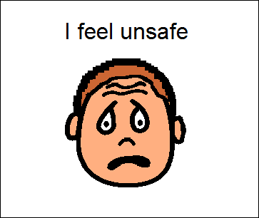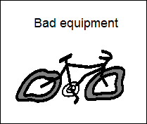

 **What do you want to see happen?**   
 _____________________________________

_____________________________________

_____________________________________

** Staff please attach complaint follow-up to this form